SIMATS ENGINEERING
CO4 – AT1 EXPERIMENTS
COURSE NAME: Cryptography and Network Security
COURSE CODE: CSA5160
NAME: BHUVANESHWARI B A REG NO: 192421195
1) RSA-Based Digital Signature
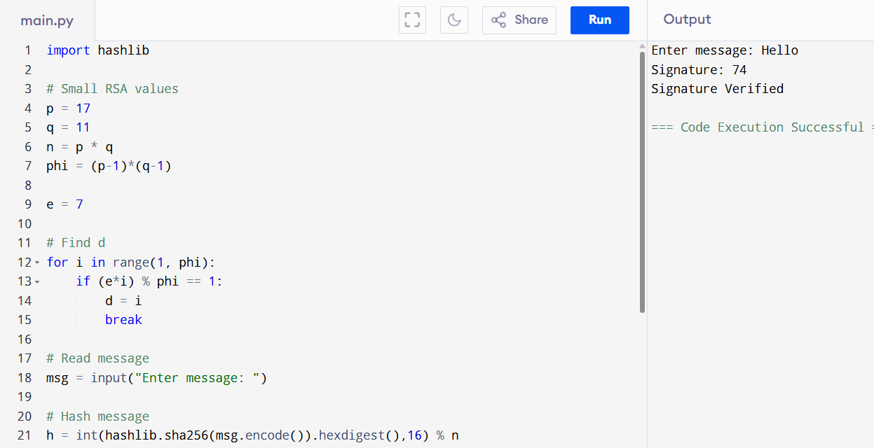

2) Diffie-Hellman Key Exchange with AES
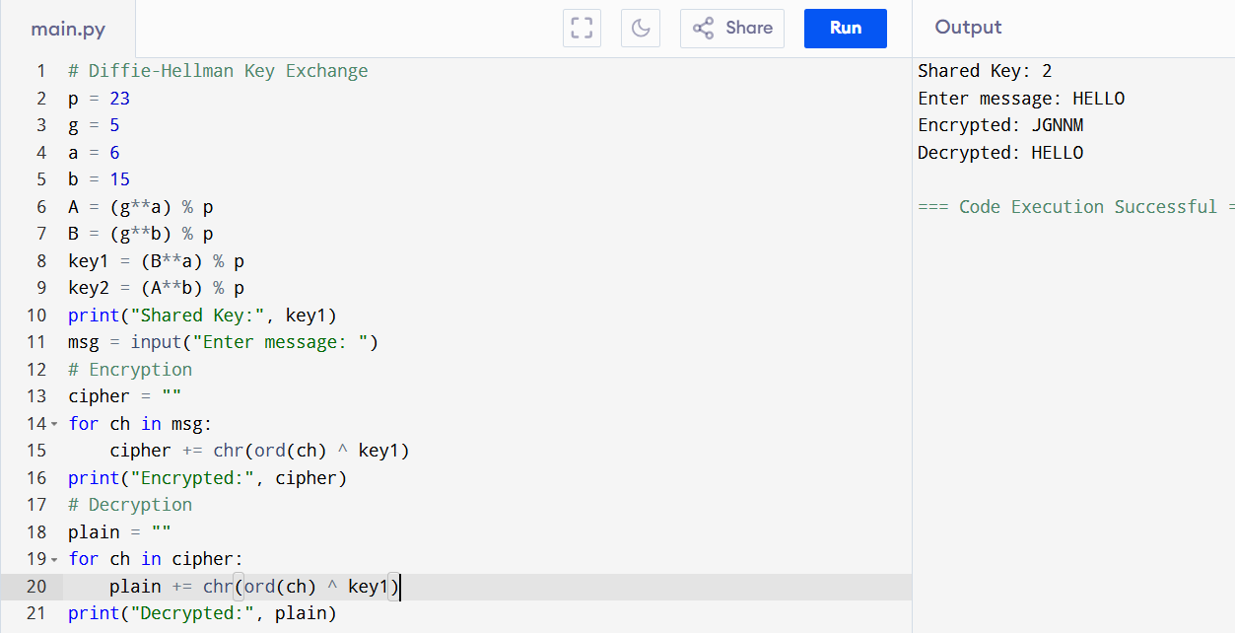
3) SHA-256 Hashing with Salt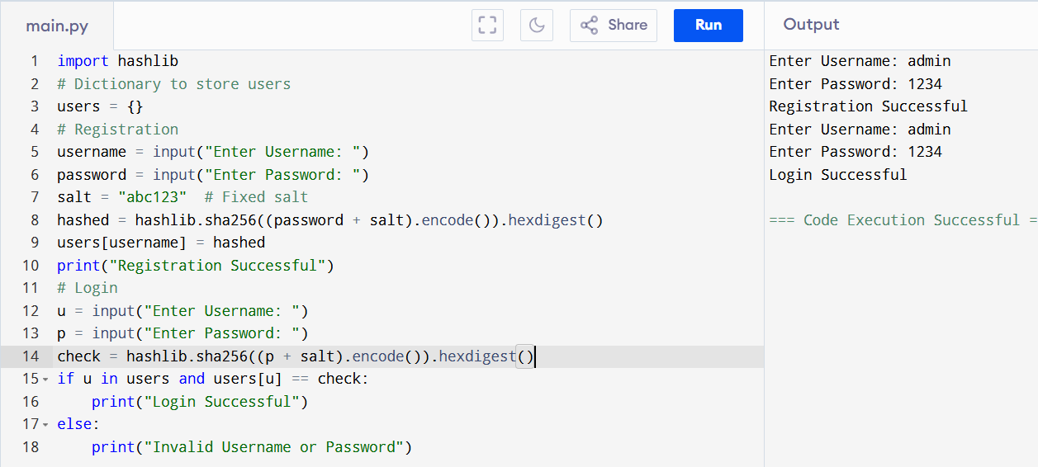
4)X.509 Certificate Parser
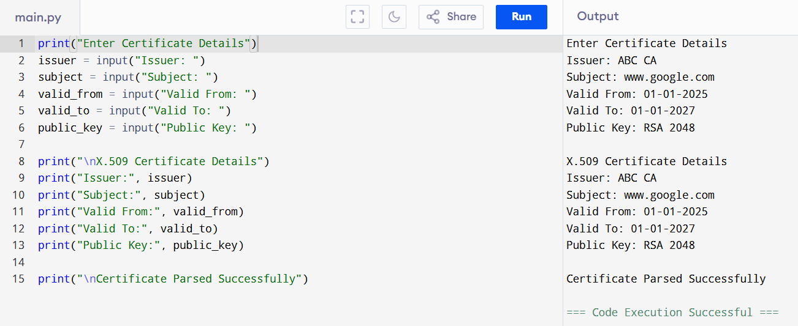
5) Intrusion Detection System (IDS)